New network assistance guide

In Ubuntu 22.04 and newer versions, the traditional /etc/network/interfaces file is no longer used for network configuration. Instead, Ubuntu has adopted the use of Netplan to manage network configuration.

To configure network interfaces in Ubuntu 22.04 and later, follow these steps:

Check the available network interfaces:
You can use the ip command or ifconfig command to list the available network interfaces. Open a terminal and run:
Ip a
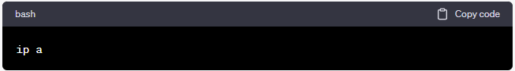or

bash
ifconfig -a
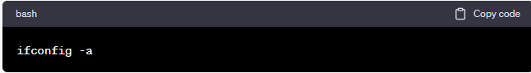
This will show you a list of network interfaces along with their names (e.g., eth0, ens33, enp0s3, etc.).

Create a Netplan configuration file:
Netplan uses YAML configuration files to define network settings. Create a Netplan configuration file in the /etc/netplan/ directory. You can name it something like 01-netcfg.yaml:
sudo nano /etc/netplan/01-netcfg.yaml
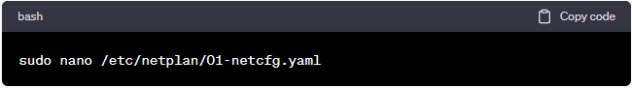
Replace nano with your preferred text editor if you have one.
Configure your network interface in the Netplan configuration file. Here's an example of a basic configuration:
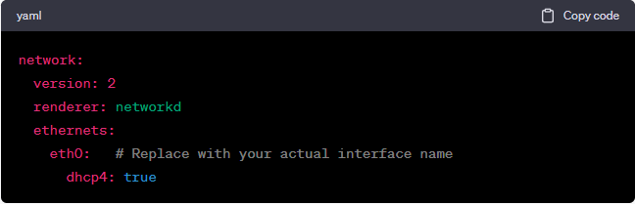
network:
version: 2
renderer: networkd
ethernets:
eth0: # Replace with your actual interface name
dhcp4: true
In this example, we configure eth0 to obtain an IPv4 address using DHCP. Make sure to replace eth0 with the actual name of your network interface.

Save the configuration file and exit the text editor.

Apply the configuration changes:
sudo netplan apply
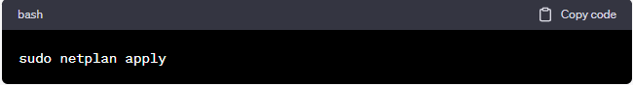
This command applies the changes you made in the Netplan configuration file.

Verify the network configuration:

You can check the network status and the assigned IP address by running:
ip a
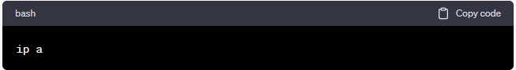
This should display the network configuration for your interface, including the assigned IP address if DHCP is used.

With these steps, you should be able to configure your network interface in Ubuntu 22.04 without needing the old /etc/network/interfaces file and the ifup command.

